The enigmatic “Tartessian” Monuments of South Portugal.
G.J.Boekschoten and J.H.Looijenga

In South Portugal, between the plains of Lower Alentejo and the mountain ridge that separates this region from the Algarve, lies an area which has preserved about a hundred large stones with inscriptions, originally stelae with a monumental function. They are known as Tartessian Monuments, although the region called Tartessos in ancient times is in southern Spain. The inscriptions are in the so-called south-west script, one of the three known Iberian or paleo Hispanic proto historic scripts. Unfortunately the Tartessian Monuments have no date, since they have been found in secondary contexts. It is presumed that the inscriptions were made between the 8th and 5th centuries BC (datings vary greatly), although this is by no means certain. Several theories about the origin of the script and the language have been offered of late. One of the most intriguing theories is that the language may be some form of Celtic, and even that the Celtic culture originally spread from this southwestern part of Europe to elsewhere. In this lecture we will first and foremost concentrate on the context of the inscribed stelae.
One thing should be stressed, however. The names Tartessos and Tartessian monuments are actually misleading, because the region called Tartessos in the Antique was quite somewhere else, in South-West Spain, around Huelva at the mouth of the Guadalquivir river and its hinterland (fig. 1). That region was wealthy, had rich burials, could boast an enormous amount of precious ores, such as tin, gold and silver. The eponymous name of the mythical king was Argontonios – Gr. αργός, Lat. argentum, Celt. arganton ‘silver’- small wonder that the Phoenicians who came to Tartessos in the 9th century BC showed great interest in this country. Between this core region of Tartessos and the SW Portuguese region of the stelae is a large distance (see map 9.1. in Koch 2010:187). There may have been contacts between Tartessos and the Algarve/Alentejo region with the inscribed stelae – but the differences are significant. First of all the stelae with inscriptions are for the greatest part found in the Portuguese SW region – of a total of 95 inscribed stelae only 3 have been found in the core region of Tartessos – and 4 in Extremadura. The region of the stelae was by no means rich and had no rich burials to show for a wealthy elite. “Status markers are totally lacking from south-western Iberia which at this stage had ceased to be an integral part of the Atlantic Bronze Age world, probably due to the early introduction of iron technology into this area and its re-orientation toward Mediterranean trade networks, triggered by the strong Phoenician presence in the area.” (Dirk Brandherm 2013:153).
In the late Bronze Age there seem to have been in Western Andalusia, Extremadura and South Portugal “a highly similar material culture; about 90% of all Tartessian objects from the Iberian Peninsula have been found in these areas” (Chamorro 1987:203). But after 600 BC, in the Classical Iberian period, these similarities seem to stop. A significant problem is that many authors writing on Tartessian culture make no difference between the several regions mentioned above – the name “Tartessian” is used indiscriminately for all three regions. The SW area and Extremadura both have decorated stelae – the latter has so-called warrior stelae (Extremadura, Badajoz, Medellín). The difference between is that the warrior stelae are decorated with figures and objects like swords, shields and chariots, while the inscribed stelae have letters. Therefore, they may very well present different periods and different cultures (there are two stelae with both pictures and text – both far outside the core region and it might very well be that the text is added much later).
In the 13th Century B.C. the Phoenicians, then an enterprising and rapidly growing nation of traders and mariners, ventured into the Atlantic and established Cadiz (1240 B.C.). They soon spread a short distance inland to Huelva, where they discovered and began to work an enormous mass of cupriferous pyrite which is still the largest of its type in the world, although it is now regarded primarily as a source of sulfur. Subsequently the deposits at Rio Tinto and the neighboring Tharsis (Tartessos) became one of the most important sources of copper.
The abundance of precious metal was what interested the Phoenicians and others from the Mediterranean world so much that they ventured out to the West, beyond the Pillars of Hercules to face the dangerous Ocean. They came for exploring the metal bearing mountains of the Iberian Pyrite Belt. It is well-known that Phoenicians and later Carthagenians established several colonies in the Mediterranean basin and in many Atlantic areas acting as innovators and dispensers of technical skills and know-how during the contacts with local cultures. The Phoenicians started the trade from the 9th c BC onwards – and they introduced their script and the art of writing into the SW world. Therefore the SW inscriptions may be dated from about the 8th c onwards – but as is shown, this dating is purely hypothetical.
Geology of South Portugal
The “Tartessian” monuments of South Portugal are clearly linked to the presence of iron and copper ores in that region. And so my story has to start pretty long ago – at 330 million years; in these times Iberia was part of a granite continent bordered southward by an ocean. At the submarine seaward slope of the continent, submarine avalanche draped a huge mantle of sand and mud. In this mantle, hot springs forced springs loaded with salts of copper and iron. You may know such springs from deep-sea pictures, where they are named black smokers. Around these and such springs special ore minerals were and are secreted, principally as pyrites.
Subsequently, mountain building took place and the muddy strata were indurated to greywacke, and uplifted to a slow mountainous landscape similar to the Welsh coast at Aberystwyth. Greywackes are poor quality fissile stones strata and greywacke soils are unfertile. The ancient volcanic springs deposits weather to hard and striking masses of oxydised mineral, called iron cap rock, by miners. They are rarely seen in the western world, as nearly all have been mined away from the metallic ages onward. Sometimes minor occurrences are accidently opened when new roads are bulldozed through greywacke country. You see here (fig. 2) such an exposure: greywacke around, in the middle dark brown iron minerals resulting from iron pyrites, and spectacular blue-greens from weathered copper pyrites – in large masses. These minerals are classic and easily treated copper ore, such as the classic ores of Timna in southern Palestine, and of superficial rocks of Cyprus. Both the weathered and the unweathered ore minerals occur in the greywacke regions now known as the Iberian Pyrite Belt.
The iron ores were conspicuous, and the colourful copper ores still more so (fig. 4 and 5); and could not escape the attention of the early inhabitants of the greywacke area. But it is unlikely that they themselves had any use for this material, and had any metallurgical know-how. It seems more plausible that they shared information with foreign prospectors, such as Phoenicians, Etruscans or Carthagenians. Mining and ore processing in the Pyrite Belt was hugely successful. Greenland ice strata from 400 BC onwards contains increasing quantities of copper and lead particles, proving worldwide air pollution as a result.
It is in the vicinity of such southern Portuguese mining localities that the stone slabs with “Tartessian” inscriptions are found, in the western part of the Pyrite Belt. About a hundred of these are known. They are roughly worked, and if entirely preserved rectangular shaped with a lower side that is uninscribed indicating that the stones were intended to stand upright with half of the slab in the soil (fig.3). Traces of natural wear prove that most were procured from naturally exposed stone strata, not from special quarries. Traces of weathering of the slabs differ for parts supposedly in the open air, and those that were buried for some time. No Tartessian stone, however, was ever found in its original upright position, although virtually all are clearly connected to Iron Age burial grounds. This may suggest that the Tartessian monuments belonged to graves that subsequently were robbed.
Perhaps there is a modern analogue to these old grave fields. The very same Pyrite Belt mines were reopened in the middle of the 19th century by British enterprise. The largest was the Spanish Rio Tinto mine, opened in 1873 and still presently a corporation dominating the mineral mining world. The miners were Portuguese, or Spanish – the engineers were British, and the latter had their own cemeteries, of course with English inscriptions illegible to the miners of which a large number was illiterate. The Tartessian inscriptions, in this line of reasoning, could have been memorials to foreigners meaningful only to fellow-foreigners belonging to a special social sector connected to the mining operations in the later Iron Age.
Language and writing in Iberia
One of the problems we encounter is the nature of the language of the inscriptions – it is as yet not decided unanimously what it represents: a non-Indo European language, an IE language, or a totally unknown language. Iberian has been advocated, being a non-IE language, and among the IE languages Celtic is proposed. Therefore it is of the utmost importance to establish the context of the monuments and their age.
One of the most intriguing theories that has been put forward is that the language of the texts is IE and above that, Celtic. John T. Koch has written extensively about this; see for instance Koch 2010:185: “Probably or possibly Celtic forms are of sufficient density to support the conclusion that Tartessian is simply a Celtic language, the oldest attested one, rather than a non-Celtic language containing a relatively small proportion of Celtic names and loanwords.” Indeed, this might be so, in historian times, since the 5th century BC at any rate, when Herodotus wrote about Celts being the “westernmost inhabitants of Europe, except for the Cynetes.” (Koch 2010:186).
Three major writing systems were used in the Iberian Peninsula from the Iron Age to the Roman Age. They are referred to generally as Paleohispanic scripts: the south-western script, the south eastern and the north eastern script. (See for more details Valério 2014:440). Transliteration started with north-eastern, which represents Iberian, a non-IE language. Transliteration does not mean translation, and Iberian is still not quite well-known. But one main thing to keep in mind is that if we do not know which language was presented by the signs on the stones, we cannot exactly transliterate these signs – since we do not know which sounds they represent.
The north-eastern Iberian semi-syllabary was later adopted by the Celtiberians in the hinterland – whose language is IE (Miguel Valério 2008, 107,8). Jürgen Untermann (2003, 2004:175) cautiously speaks of a chronology of the Iberian scripts: the Iberian originates from between the fourth and the first c. BC, the Celt-Iberian script between 150 and 50 BC and the Tartessian script between 500 and 200 BC, because “otherwise than with the other groups there are no archaeological datings for the Tartessian monuments: terminus post quem is the supposed time in which the ancient Hispanic script was designed, and terminus ante quem is the Romanization of the south west peninsula.”
According to Untermann (1995, 244) “Thus far, their archeological context has been inadequately investigated: it is assumed that they (the inscribed stelae, TL) are to be dated to the period 700–500 B.C.E., and that in most instances the inscriptions are funeral in nature. The script has been deciphered with some degree of thoroughness and security in recent decades, once it had been established that it was a variant of the much better attested and interpreted Old Hispanic scripts attested in the south and east of the peninsula. The linguistic analysis of the texts, which are engraved in scriptio continua, began with the identification of a few formulaic words, and then, more or less securely, with personal names. Some of the latter seem to exhibit Celtic etyma and flexional elements; the formulaic segments do not completely exclude the possibility that the language of the corpus is Celtic. A conclusive decision cannot be taken yet.” Again it is necessary to underline that the transcription is uncertain. The letters in one language may present another sound than in another language – especially when both languages are very much apart.
One very important stone is the Signary or Table of Espanca, found near Castro Verde in Baixo Alentejo, Portugal (fig.6). Unfortunately it has no archaeological context and no date. Its inscription is a two-line abecedarium of 27 letters; one is the example and the other the copy. Perhaps a writing exercise? The order of the first 13 letters closely reflects that of west semitic alephats, such as the Phoenician one, although tau comes before wau (cf. Valério 2008:114). It has signs for vowels, which reminds of the Greek writing system with five vowels, called matres lectionis. In short, the “adoption of writing in the Iberian Peninsula is part of a process of “Mediterraneanization” increasingly intensified since the Bronze Age”, according to Valério 2008:117. It reminds strongly of the Kylver runestone from Gotland, dated circa 400 AD (fig.7). It has a complete futhark, the oldest representation as far as we know. The alphabet of Espanca has an additional set of letters that are not of west semitic fashion; they were used to cover phonological gaps and are probably graphic variants or back-formations (Valério 2008:118,9) from Phoenician letters, thus producing a semi-syllabary. The extra letters were used for syllabic sets for b, k and t series: like ba, be, bi, bo, bu and ka, ke, ki, ko, ku and ta, te, ti, to, tu.
The relation between this script and the other Paleohispanic scripts is still under hot debate, so I will not go into this subject. Another hot debate regards the matrix alephat or alphabet: Phoenician, Greek, or Punic. As Valerio (2008:114) points out: “the choice of a particular type of script is largely dependent on the inherent features of the language beneath”.
Motivation
The reason for our research into the so-called Tartessian inscriptions was triggered by their striking resemblance to the Scandinavian rune stones. To be sure: they have nothing to do with each other, it is the resemblance of both the monuments and the questions that arise when wondering about the use of script by people living far beyond the civilized world. For instance in both cultures: northern Europe and southern Iberia, the surface of the stones was carefully prepared before inscribing; sometimes the inscriptions are unfinished and it seems that some signs have been added later. The text was often inscribed between straight lines. Word dividers are very rare. Also in both cases there is the impression that the carver was not literate; he just carved from an example. Both runic and Tartessian script runs from left to right and from right to left, up and down, also boustrophedon. Most monuments were meant to stand vertically, which can be seen from the shape of the stone: the lower part had a large foot to be inserted in the ground and the upper part was prepared for the inscription.
The main question in both cases is what caused people to adopt a script from speakers of a foreign language and adjust it to represent their own language? And why would people living in humble agrarian circumstances design a script for which they apparently had no obvious use, other than for funerary memorials? When adapting script from the Phoenicians, or maybe from the Carthagenians or the Greek, they had to adjust the letters to their language, which means that the people who did that needed to be totally literate, in Phoenician and their own south-west (SW) Iberian language. Both languages differed in sound system so some Phoenician letters found no counterpart in SW, and sounds occurring in SW had no counterpart in Phoenician. Therefore, letters had to be discharged or given another sound value, some new letters had to be designed, in a fitting manner to the old Phoenician alephat. The same procedure we know from runic script: the matrix alphabet, be it Latin, or Etruscan, or Greek, had to be modified to make it work for the Old Germanic languages. The same question arose: did the old Germanic rune writers do this only for writing memorial texts and names? Why go into such a difficult job when nearly nobody could read and write in their near surroundings? This can be asked of the indigenous population of the Alentejo and the Algarve: why did they erect large stones with inscribed texts in an almost illiterate world? Or was it done by others?
A script was designed either for 1) communicative purposes between those who were literate (say the ore exploring elite), or script was used 2) for markers indicating property or boundaries. Communicative purposes of script is of course not an issue in an illiterate society. So, who were the literaci?
On the other hand, perhaps the monumental stelae were seen as objects of worship or symbols of power, especially because they had texts – making them more awesome still – and a function as marker of property or boundaries is seen more often: e.g. Ogam stones in Ireland and Wales, picture stones on Gotland.
The Portuguese archaeologist Rodrigues Ramos (2002:93): observes that the majority of the villages to which the stelae belonged are the same that controlled certain routes over the mountains. These routes were used for trading ore and metal between regions with a wealthy culture. In his abstract (2002:85) he formulates it thus: “The spatial analysis allows to conclude that in South Portugal the steles are aligned according to a trading route that goes to the Ajustrel mining zone and to the Sado basin, but not controling the mining resources. This trading route carried the goods to the few local stele concentrations of the Algarve and to the Phoenician colony of Rocha Branca on the south coast of the Algarve.”
A secondary context?
A complicating factor is that the monumental inscribed stelae are claimed to have not been found in their original site, all of them have been reused – so we are faced with a lack of original context. A certain sequence of letters occurs frequently, so this may be taken as a formulaic kind of text. But of what content is unknown, however, some scholars take it as a “funerary formula”. This is because most stelae are supposed to have a funerary (secondary) context: some have indeed been found in cemeteries. These graves, or grave mounds, have been dated to between the 7th and 5th centuries, so the stelae must be older. Or, there is no question of a secondary use in these burials, and we may assume that at some time the stelae which stood upright have fallen down and got buried in the graves they belonged to. In one case a broken piece of an inscribed stele has been found as part of the pitching (encachado) amidst other boulders on the outside coating of a tumulus, in the cemetery of Medellín, 200 kms north of the Tartessian area. This tumulus has been dated to 525-500 BC (Almagro Gorbea 2004). It is a small fragment of a carved stele tartésica of gray schist, only part of the right and upper side is preserved. Broken and reused among river pebbles forming the outward stone setting of the tumulus 86H / 12 of the necropolis, found in 1986. A photo of the fragment (Almagro Gorbea 2004:33) clearly shows the piece with the inscription that was preserved and reused. (translation of Almagro Gorbea’s text).
The fragment bears an inscription with the ‘formulaic’ words (i.e. words that appear often in the inscriptions) lokon and narke(n). The original stèle may therefore have been older, but nobody knows how much older. Koch’s (2013:101) argument that “Recent archaeological work on the Medellín necropolis (Badajox, Spain) confirms that a mature and standardized form of the South-western (SW) or ‘Tartessian’ script was in use from westernmost south Portugal to the upper Guardiana, by the mid 7th century BC” is pure speculation and should be dismissed since the fragment may very well have been added later to the pitching (exterior) of the tumulus. It is known that secondary graves were added to existing tumuli, or that graves were reopened for some cause, things were taken from a grave or just added. The fact that the fragment had two apparently significant words (lokon and narke(n)) might have made it special and suitable (only if the builder knew what these words meant, which is quite possible, also in case he couldn’t read).
Rodrigues Ramos elaborates about the archaeological context (2002). He comes to the conclusion that on archaeological analyses of the few datable contexts the stelae with inscriptions should be dated most likely in the 6th – 5th centuries. He adds that the majority of the inscriptions show archetypical formulae and have a funerary context. The context they are found in does not represent a particularly rich culture. This is in contrast with the actual Tartessos region around Huelva.
The chronology may be that after the Phoenicians, came other merchants such as Greek and Carthagenians (since the 8th c BC). Another ancient population in the region who also might be considered as makers of the SW inscriptions are the Conios or Cynetes, because some inscriptions may show an appelative “konii”. And last but not least, the authors may be Celts, who came to live in the area just before the Romans conquered Iberia. But since there is a lack of archaeological, we have no way of knowing who, when and why these mysterious monuments were made.
Herodotus (ca 480 – 425 BC) mentions the homeland of the Celts near Pyrene, which lies near the source of the Istros – the Danube - . He compares the rivers Nile and Istros, because they are both long rivers that separate large parts of the world. “because the Istros, which begins in the land of the Celts near the town of Pyrene, runs right through Europe. The Celts live outside of the Pillars of Hercules and border the land of the Cynetes, who are the utmost western population of Europe”. The Celts therefore had the Kynèsioi (Cunesei) as neighbours in the south of Spain or Portugal. It concerns a region that reaches from the Ocean in the west far into the eastern part of the land. Right behind the Pillars is Cadiz (Gades) and the land around it is Tartessos. The kingdom of Tartessos collapses around 500 BC and the region might have been repopulated by Celtic speaking people. If they were the makers of the monuments, this would suit the dating by Rodrigues Ramos, of the 6th – 5th century.
It is not easy to establish when exactly Celtic speaking people arrived – but at any rate it was from the 5th c BC onwards, because Herodotus mentions them in his writings. It was also a period when strongholds were build and a kind of hierarchic system arose. According to Dirk Brandherm (2013:148) it was in “the mid first millennium BC when the presence of Celtic speakers is attested for both northern Italy and south-western Iberia”. You would rather expect such a building hierarchic community would profit from a writing system, but it seems by then the SW script stopped (depending on which dating you prefer)! That may have something to do with the collapse in population, for which no reason is known. It should be mentioned that settlements in the Tartessos region (around Huelva) were inexplicably abandoned in the 5th century .
Some arguments on the problematic nature of the language of the inscriptions.
To begin with, John T. Koch points out in JIES 42, 2014:…. “the theory that the language of the corpus, called tartesio ‘Tartessian’, was Celtic was first formulated by the philologist José Antonio Correa of Seville in the 1980s and early 1990s (cf. Correa 1989; 1992). By the mid 1990s, Correa had re-formulated his position, now seeing the corpus as embodying Celtic names within a different, probably non-Indo-European, matrix language; however, he offered no proposal about the matrix language as a particular known non-Indo-European language or the relative of one (Correa 1996).”
Jesús Rodriguez Ramos (2001d:17-38): “In contrast to what is alleged, the language of the inscriptions is not Celtic, Anatolic or even IE, and also not Iberian or Berber.” He proposes that, “according to the existing evidence, it should be considered seriously that, if Basque, Aquitanian and Iberian are related languages, as the latest discoveries seem to prove, these linguistic family came into the Iberian Peninsule with the Urnfield culture” (late Bronze Age, 13th c BC). And in a paper of 2002 he argues that “the grounds of the Basque-Iberian theory are revised according to the latest studies on the Iberian language. For this purpose the evidence provided by the Iberian language (its phonology, morphology, lexicon and syntax) is put forward and analysed, pointing out both its resemblances and differences to Basque. Though the data from the Iberian language known with certainty are actually very few, it's worth observing the high percentage of matching data that is rather doubtful to attribute to chance, so making the genetic kinship between Iberian and Basque languages very likely”. If he is right, this may implicate that the language of the SW inscriptions is related to the group Basque, Iberian and Aquitanian – this theory should be further investigated.
Eska in BMCR 2013.12.35: “Given that much of the corpus, unlike the undoubtedly Indo-European Celtiberian language, cannot be parsed and that Tartessian phonology appears to be distinctly Iberoid, I am entirely in agreement with such an opinion (Zeidler’s opinion on Tartessian being a non IE language, see below, TL). Readers should approach the Celtic from the west enterprise, which must rely solely upon linguistic evidence, with the greatest of sceptism”.
Joseph Eska (JIES 42, 2014, 428-438) concludes after a thorough analysis of Koch’s arguments to establish Tartessian as a Celtic language that it is most likely Iberian, because “its Iberian phonology and the fact that many of its word terminations are identical to Iberian suggest that we should be looking in that direction.” Interesting is his remark that “Celtiberian (…) adapted its script from the non-Indo European Iberians
Jürgen Zeidler, in his BMCR review of Celtic from the West 1, suggests that Tartessian may be a non-IE language containing a large number of Celtic onomastic forms. He finds Koch’s analysis not convincing. “The reader is left with a number of inconsistencies, in form and content, ad hoc solutions and divergencies from the other Hispano-Celtic sources.” He also observes that “the presence of Celtic speakers by the time of Herodotus (c. 484-425 BC) or earlier is suggested by personal and tribal names such as Arganthonios (*arganto- ‘silver’) and Kunetes (*kun-et- ‘hound’ (warrior). Whether this has a bearing on the Tartessian inscriptions of the 8th – 6th centuries BC, however, remains problematic.” (Zeidler BMCR 2011.09.57.) “Correspondences with various Indo-European languages do not prove more than subsequent phases of mutual influence. It is hardly possible to determine the space and time of these contacts.”
Dagmar Wodtko “The problem of Lusitanian” (2010:362): “The assessment of the linguistically Celtic and non-Celtic features in western Spain, Galicia and Portugal depends crucially on the interpretation of the evidence (…). Interpretations suggested so far are by no means unanimously accepted.”

Conclusion
The language of the stelae from the southwest of the Iberian peninsula has not been accepted by philologists and other linguists as the first attested Celtic language. The linguistic mainstream continues to treat Tartessian as an unclassified language, and Koch's view of the evolution of Celtic is not generally accepted. The conclusion is that these stelae and their inscriptions, as well as their context, need more investigation. The dating of the inscriptions is most crucial, so the focus should first and foremost be on finding sufficient datable material. The find history of all stones should be reinvestigated closely and some excavations should be carried out to find out as much as possible of the context. Alternative readings and interpretations should be welcomed – in view of the suggested Iberian/ Basque, or Celtiberian background of the inscriptions. One should take a different viewpoint - try Occam’s razor: which script and language is most likely to be found on the stones – taken that a narrower dating can be achieved as a starting point.
References
Almagro-Gorbea, M. 2004 “Inscriciones y Grafitos Tartésicos de la Necropolis Orientalizante de Medellín”, Palaeohispanica 4, pp. 13-44.
Chamorro, J.G. 1987 “Survey of Archaeological research on Tartessos”, American Journal of Archaeology 91/2, pp. 197-232.
Correa, 1989 “Posibles antropónimos en las inscrpciones en escritura del SO. (o tartesia)”. Veleia 6, pp. 243-252.
Eska, J.F. 2013 “Review of John T. Koch, Barry W. Cunliffe (ed.), Celtic from the West 2: Rethinking the Bronze Age and the Arrival of Indo-European in Atlantic Europe. Celtic studies publications, 16. Oxford; Oakville, CT: Oxbow Books, 2013. Pp. viii, 237. Bryn Mawr Classical Review BMCR blog 2013.12.35.
Eska, J.F. 2014 “Comments on John T. Koch’s Tartessian-as-Celtic Enterprise”, JIES 42, vol.3/4, pp. 428-438.
Guerra, Amilcar, 2009 “Novidades no Âmbito da Epigrafia Pré-Romana do sudoeste Hispânico”, Lalaeohispanica 9, pp. 323-338.
Koch, John T. 2010 “Paradigm shift? Interpreting Tartessian as Celtic”, Celtic from the West: Alternatice Perspectives from Archaeology, Genetics, Language and Literature. Oxford. Pp. 185-301.
Koch, John T. 2013 “Out of the flow and ebb of the European Bronze Age: Heroes, Tartessos, and Celtic”. Celtic from the West 2: Rethinking the Bronze Age and the Arrival of Indo-European in Atlantic Europe. Celtic studies publications, 16. Oxford. Pp. 101-146.
Koch, John T. 2014 “On the Debate over Classification of the Language of the SW Inscriptions, also known as Tartessian”, JIES 42. Vol. 3/4. Pp. 335-427.
Jesús Rodriguez Ramos, 2001d "La cultura ibérica desde la perspectiva de la epigrafía: un ensayo de síntesis", Iberia 4, pp. 17-38.
Jesús Rodrigues Ramos, 2002 “Las inscripciones Sudlusitano-Tartesias, Su función, lengua y context socio-economico” Complutum 13, pp. 85-95.
Jesús Rodriguez Ramos, 2002c "La hipótesis del vascoiberismo desde el punto de vista de la epigrafía íbera" , Fontes Linguae Vasconum 90 mayo-agosto 2002, pp. 197-216.
Untermann, J. 1995 “Zum Stand der Deutung der “tartessischen” Inschriften”. Hispano- Gallo- Brittonica: Essays in Honour of Professor D. Ellis Evans on the Occasion of his Sixty-Fifth Birthday. Cardiff. Pp. 244-259.
Miguel Valério, 2008 “Origin and development of the Paleohispanic scripts: the orthography and phonology of the Southwestern alphabet”, Arquologia, vol. 11, número 2, pp. 107-138.
Miguel Valério, 2014 “The Interpretative Limits of the Southwestern Script”, Journal of Indo European Studies, Volume 42, Number 3&4, pp. 439-467.
Wodtko, Dagmar S. 2010 “The problem of Lusitanian”, Celtic from the West: Alternatice Perspectives from Archaeology, Genetics, Language and Literature. Oxford. Pp. 335-367.
Zeidler, Jürgen, 2011 Review of “Barry W. Cunliffe, John T. Koch (ed.), Celtic from the West: Alternative Perspectives from Archaeology, Genetics, Language, and Literature. Celtic Studies Publications 15. Oxford/Oakville, CT: Oxbow Books, 2010. Pp. vii, 384. Bryn Mawr Classical Review 2011.09.57.

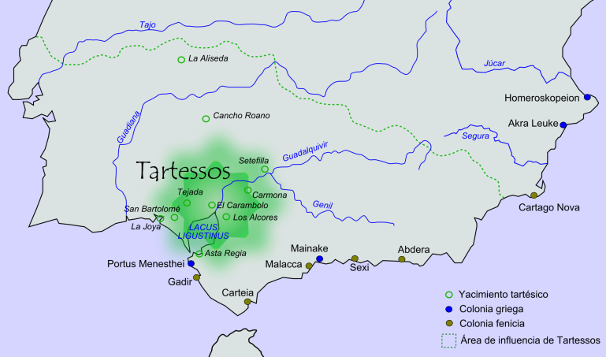 Fig. 1. The region of ancient Tartessos (source: Wikipedia). The region of the inscribed stèles is the empty space left of the Guadiana river, in South Portugal, not inside the green spot on the map.

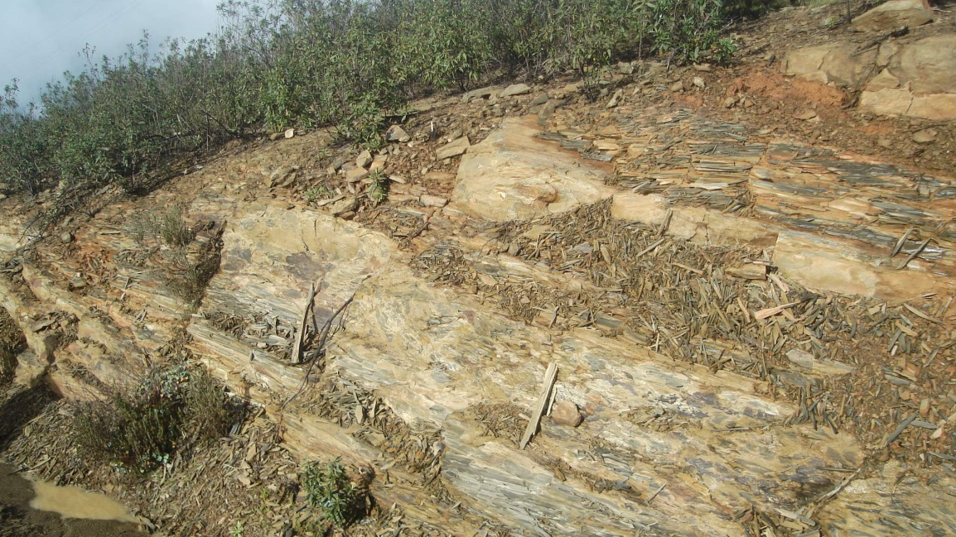
fig. 2. Graywacke near Mesas do Castelinho, Algarve, Portugal
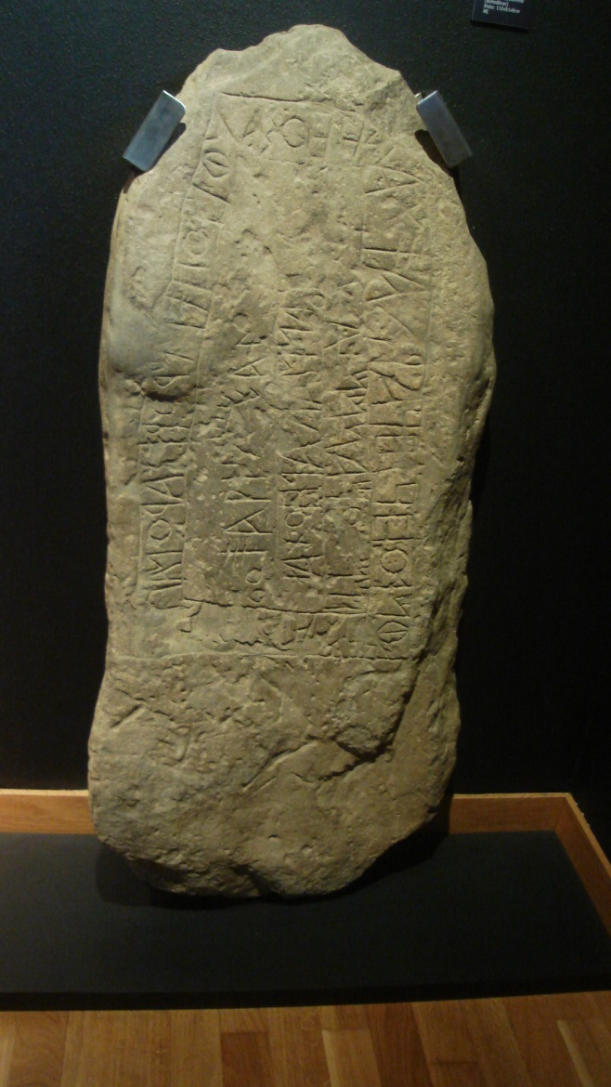 Fig 3. Stèle from Mesas do Castelinho, now in the Museu da Escrita do Sudoeste at Almodôvar, Algarve, Portugal.
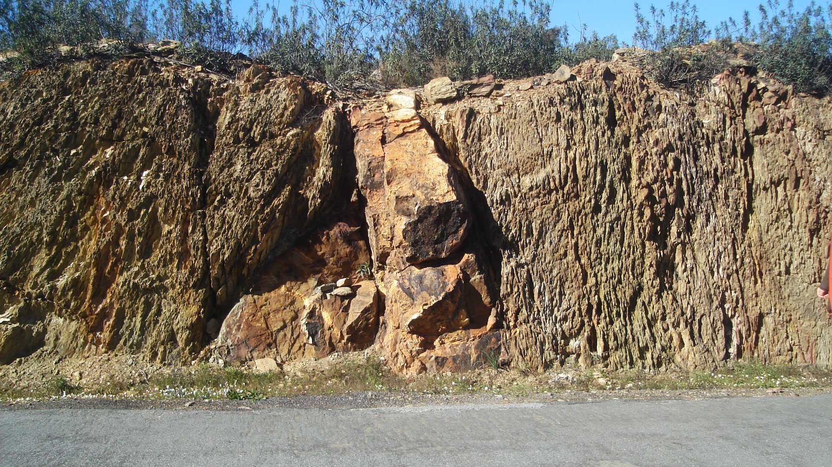
Fig. 4. Vein of copper ore at roadside to Mina de Sâo Domingos.

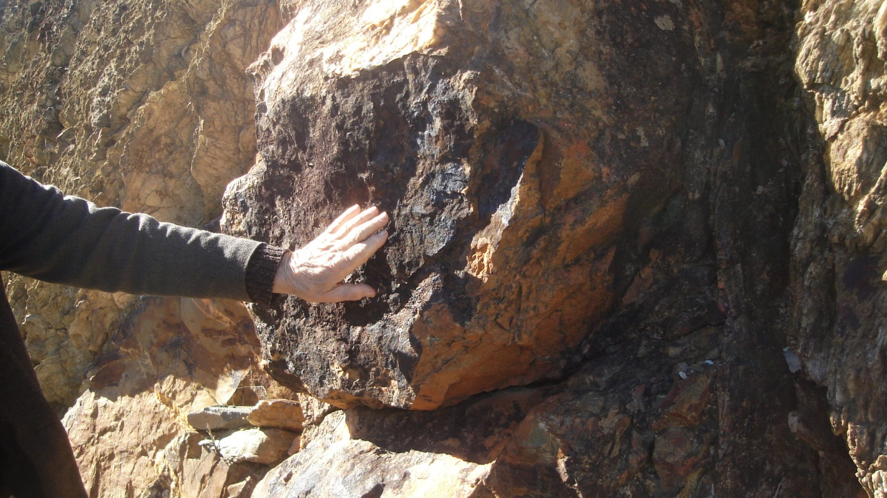
Fig. 5. Copper mineral.

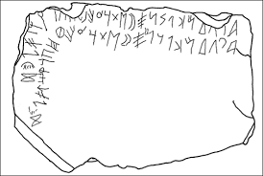
Fig. 6. Stèle of Espanca, with abecedarium.

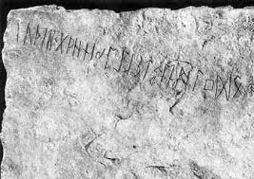
Fig. 7. Kylver rune stone, with futhark (Gotland, Sweden).

Dr. G.J. (Bert) Boekschoten is emeritus Professor Geology and Palaeontology at the Vrije Universiteit Amsterdam.
Dr. J.H. (Tineke) Looijenga is a runologist and independent researcher at Rijksuniversiteit Groningen.
The Arade river has since time immemorial been the route to the interior favoured by the vessels of the Mediterranean peoples - Phoenicians, Greeks and Carthaginians- who were drawn to the region by the copper and iron mined in the western Algarve. This much is evident from the archaeological site at Cerro da Rocha Branca - unfortunately destroyed - about half a mile away from Silves, which was inhabited from the end of the Bronze Age onwards.

